صورة تحتوي على الرسومات, تصميم الجرافيك, شعار, الخط

تم إنشاء الوصف تلقائياً

**Information Technology Department**

**College of Computer and Information Sciences**

**A secure and reliable framework for explainable artificial intelligence (XAI) in smart city applications**

**A thesis submitted in partial fulfillment of the**

**requirements for the degree of Master of Cybersecurity & Digital Forensics**

**By: Mohammad Hassan Algarni**

**Student ID: 441104419**

**Email Address:** [441104419@s.mu.edu.sa](mailto:441104419@s.mu.edu.sa)

**Supervisor Name: Dr. Shailendra Mishra**

**Email Address:** [s.mishra@mu.edu.sa](mailto:s.mishra@mu.edu.sa)

**Dec – 2023**

**Acknowledgment**

I extend my deepest appreciation to Dr. Shailendra Mishra, whose exceptional expertise and guidance have been paramount throughout the intricate journey of this research. Dr. Mishra's mentorship has played a pivotal role in augmenting both the depth and quality of this academic thesis.

I wish to convey my profound gratitude to my family, particularly my wife and sons, for their unwavering support, understanding, and encouragement. These pillars of steadfast dedication were indispensable in navigating the challenges inherent in the pursuit of academic excellence. I am deeply thankful for their patience and unwavering belief in my capabilities.

Additionally, I express my heartfelt thanks to my parents for instilling in me a passion for learning and providing a foundational support structure throughout my educational endeavors.

I extend sincere appreciation to the Computer and Information Sciences department at Majmaah University for fostering an enriching academic environment. The department's resources and opportunities played a pivotal role in contributing to the success of this research.

Gratitude is extended to my esteemed thesis committee members, [……........... 1] and [………………. 2], for their invaluable feedback and guidance.

Finally, I would like to express my sincere thanks to all the participants who willingly dedicated their time and insights to this study. Their cooperation was integral to the successful completion of this research.

Mohammad Hassan Algarni

Master of Cybersecurity & Digital Forensics

Majmaah University

December 2023

**List of Figures**

Figure 1 Healthcare research in XAI in smart city [1] 10

Figure 2 Blocks of Smart city. 11

Figure 3 Types of XAI 12

Figure 4 trustworthy in smart city 13

Figure 5 securities challenges 14

Figure 6 classical vs latest XAI integration in smart city 18

Figure 7 Classical xai method 20

Figure 8 Security in smart city using XAI. 21

Figure 9 Research methodology 27

Figure 11 CVS of dataset 38

Figure 12 check null values 39

Figure 13 cities and countries names 40

Figure 14 Continents names 40

Figure 15 Data preparation 41

Figure 16 total cities 41

Figure 18 Heat map for continents 43

Figure 20 Code for Lime Logistic regression 45

Figure 23 output for random forest Shap 46

Figure 24 Shap interaction value 47

Figure 25 performance metric for LIME 49

**List of Tables**

Table 1 Related Articles and Cyber security majors 23

Table 2 Research Management Plan 31

Table 3 System Requirements 33

Table 4 comparative analysis with previous research 51

**Table of Content**

***Chapter 1*** 9

***Introduction*** 9

1.1 Introduction 9

1.2 Background 11

**The role of explainable artificial intelligence xai** 12

1.3 Research objective 13

1.4 Research Challenges 13

Research Challenges in xai for smart Cities 14

1.5 Research Motivation 14

1.6 Research Questions 15

1.7 Statement of Problems 16

1.8 **What has been done so far and how this research paper is better** 16

**1.9 Structure of the thesis** 16

**1.10 Conclusions** 17

Chapter 2 18

Literature Reviews 18

**2.1 Introduction to smart cities and AI Integration** 18

Traffic Management: 19

Healthcare: 19

**2.2 The Need for Explainable AI (XAI)** 20

**2.3 Security Challenges in Smart City Applications** 21

**2.4 Related Articles & Cybersecurity Majors:** 23

**2.5 Research gaps** 24

**2.6 Research objectives:** 24

**2.7 Findings of Literature Review** 25

**2.8 Conclusions** 25

**Chapter 3** 26

**Research Methodology** 26

**3.1 introduction** 26

**3.2 Research Methodology** 26

**3.3 Research Design** 29

**3.4 Choosing of Research Methods** 30

Research Management plan 31

**3.5 Conclusions** 32

**Chapter 4** 33

**Implementation** 33

**4.1 Introduction:** 33

**4.2 Details of Project Implementation** 33

Tools and programming language: 34

Python: 34

Jupyter Notebook 34

Latex 34

Machine Learning Concepts: 34

**4.3 Experiment analysis** 35

**4.3.1 Core Components** 35

**4.2.2 Integration of XAI Techniques** 36

**4.2.3 Interconnections** 36

**4.2.4 Security measures** 36

**4.3 Data collection and preprocessing** 37

**4.3.1 Information sources** 37

**4.3.2 Methodology of the Smart City Index** 37

**4.3.3 Data model creation** 38

**4.3.4 Problems and solutions** 38

**4.3.5 Preprocessing** 39

**4.4 Model Development and Training** 43

**4.4.1 Model Selection for Machine Learning** 43

**4.4.2 Logistic Regression Training Process (for LIME):** 44

**4.4.3 Random Forest Regression (for SHAP):** 46

**4.4.3 Privacy and Reliability Issues** 47

**4.4.4 Model Assessment** 47

**4.5 Case Studies** 48

**4.5.1 Intelligent Traffic Management** 48

**4.5.2 Environmental Monitoring** 48

**4.5.3 Emergency Response Optimization** 48

**4.6 Conclusions** 48

**Chapter 5** 49

**Result and Discussion** 49

**5.1 Introduction** 49

**5.2 Results** 49

**Model Performance Metrics Evaluation** 49

**Interpretability Insights through SHAP and LIME** 50

**Decision-Making Processes in Smart City Applications** 50

**5.3 Discussion** 50

**Comparative Analysis with Previous Research** 50

**5. Conclusions** 51

**Chapter 6** 53

**Conclusion and Future work** 53

**6.1 Introduction** 53

**6.2 Conclusion** 53

**6.3 Limitation of the study** 53

**6.4 Scope of Future Work** 54

Bibliography 56

**Abstract**

Living in a smart city has many advantages such as improved management of waste and water access to quality healthcare facilities effective and safe transportation systems and personal protection when an ai system is able to provide explanations for its judgments or predictions it is called explainable ai xai this term is used to describe an ai model its expected impacts and any potential biases that might be present there exists a set of tools and frameworks known as explainable ai that can aid you in comprehending and having faith in the output and outcomes generated by machine learning algorithms these advancements are vulnerable to a diverse array of security issues encompassing theft of information covert listening attacks obstruction of service delays in communication manipulation of data cyber attacks on io t security interception of communication disruption by interference signals malfunctioning sensors insecure application programming interfaces ap is and exploitation from a remote location this study aims to develop a secure and reliable framework for explainable artificial intelligence xai in smart city application

# ***Chapter 1***

# ***Introduction***

In this chapter we establish the context for our investigation into explainable artificial intelligence xai in smart city applications the importance of understanding and interpreting judgments made by intelligent systems has grown as ai technologies become more integrated into urban areas the chapter discusses the necessity of transparency and interpretability in the context of smart cities focusing on issues related to complex machine learning models the v goal is to create a safe and dependable framework that harnesses the potential of ai for smart city improvements while ensuring these technologies are understandable and responsible to both citizens and decision makers

# 1.1 Introduction

The emergence of smart cities signifies a transformative epoch in urban development where innovative technologies are harnessed to revolutionize every aspect of city life this urban evolution holds the promise of optimized waste and water management superior healthcare facilities safer and more efficient transportation systems and an elevated standard of personal security at the core of this technological renaissance lies the omnipresent force of artificial intelligence ai ai empowers cities to harness data driven decision making processes enabling them to provide their residents with a markedly improved quality of life the integration of ai into the infrastructure of smart cities is akin to infusing the city with an intelligence of its own in the realm of healthcare ai systems are increasingly called upon for disease diagnosis treatment recommendations and predictive analytics a fundamental challenge remains understanding the rationale that underpins the recommendations in scenarios as critical as healthcare comprehending the reasoning behind ai driven decisions is indispensable transparency is not an option but a necessity.

Similarly the ascent of autonomous transportation systems within smart cities necessitates an equivalent level of transparency when self-driving vehicles navigate the intricate choreography of city streets their actions must be explicable and comprehensible to human stakeholders the need for explanations becomes paramount when decisions involve matters of life and safety such as lane changes and emergency stops this need for transparency and interpretability in ai has led to the development of explainable artificial intelligence xai xai represents a paradigm shift that strives to make ai models transparent and understandable to humans enabling individuals to fathom the reasoning behind ai decisions in the realm of smart cities xai plays a crucial role in ensuring that we can trust ai driven solutions and understand the reasoning behind their decisions it goes beyond mere predictions exploring the why and how of ai decision making particularly in legal and ethical contexts the ability to provide explanations for ai actions is vital for accountability and compliance the introduction of xai has brought forth various techniques and approaches to make ai models more understandable this goes beyond just explaining individual predictions xai reveals the inner workings of ai models clarifying not only what they predict but also the processes leading to those predictions by shedding light on the mechanisms of ai xai empowers users to grasp the expected outcomes and importantly helps identify and address potential biases within the system.

.

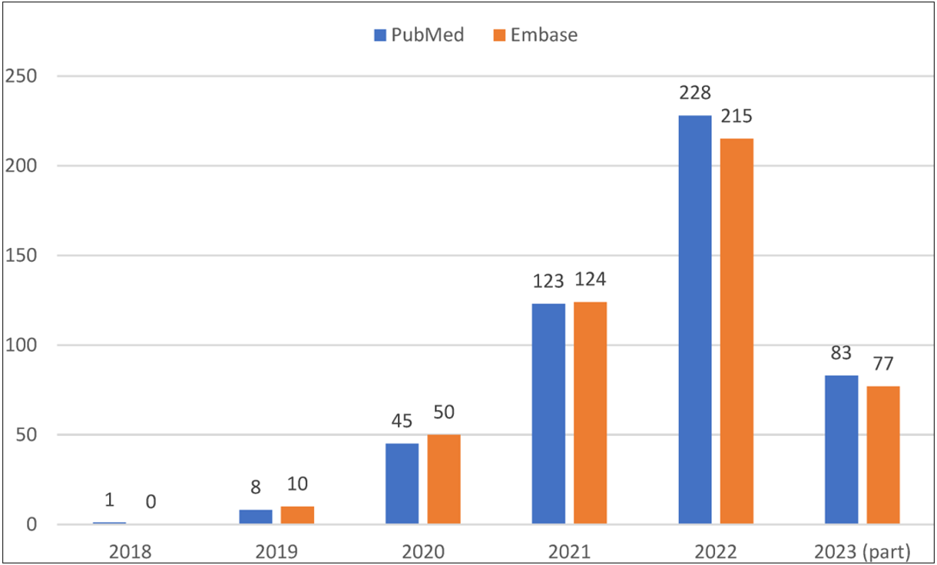

Figure 1 Healthcare research in XAI in smart city [1]

Similarly the ascent of autonomous transportation systems within smart cities necessitates an equivalent level of transparency when self driving vehicles navigate the intricate choreography of city streets their actions must be explicable and comprehensible to human stakeholders the need for explanations becomes paramount when decisions involve matters of life and safety such as lane changes and emergency stops this need for transparency and interpretability in ai has culminated in the development of explainable artificial intelligence xai xai represents a paradigm shift that strives to make ai models transparent and understandable to humans enabling individuals to fathom the reasoning behind ai decisions in the realm of smart cities explainable artificial intelligence xai plays a crucial role in ensuring that we can trust ai driven solutions and understand the reasoning behind their decisions it goes beyond mere predictions exploring the why and how of ai decision making particularly in legal and ethical contexts the ability to provide explanations for ai actions is vital for accountability and compliance. [2].

The introduction of xai has brought forth various techniques and approaches to make ai models more understandable this goes beyond just explaining individual predictions xai reveals the inner workings of ai models clarifying not only what they predict but also the processes leading to those predictions by shedding light on the mechanisms of ai xai empowers users to grasp the expected outcomes and importantly helps identify and address potential biases within the system

## 1.2 Background

Background the idea of smart cities marks a significant shift in urban living driven by the incorporation of cutting edge technologies and data driven strategies to enhance various facets of city life smart cities strive to improve urban infrastructure and services resulting in more effective waste and water management upgraded healthcare facilities safer and more efficient transportation systems and heightened measures for personal protection the integration of artificial intelligence ai systems is pivotal in these developments allowing cities to make decisions based on data automate processes and ultimately provide residents with an improved quality of life.

Figure 2 Blocks of Smart city.

Still the increasing use of ai in smart cities has created a number of issues the most notable of which is a lack in openness and interpretation in ai systems complicated ai algorithms frequently operate as black boxes making understanding the reasoning behind their decisions and forecasts difficult this obscurity raises questions about responsibility fairness and confidence in the application of ai in urban settings.

### **The role of explainable artificial intelligence xai**

Explainable artificial intelligence xai is now a fundamental approach to tackle these issues it focuses on developing ai systems that are clear and understandable allowing humans to grasp the rationale behind the decisions these systems make in the realm of smart city applications xai functions as a method to guarantee that solutions driven by ai can be comprehended and clarified thereby promoting trust and accountability among city authorities residents and stakeholders.

Figure 3 Types of XAI

Explainable artificial intelligence xai employs diverse techniques and methodologies to offer insights into ai models clarify their decision making processes and highlight possible biases by enhancing the transparency of ai xai enables users to grasp expected outcomes and plays a crucial role in identifying and correcting inherent biases in the system this is particularly significant in the realm of smart cities where ai systems often make critical decisions that impact residents lives such as in traffic management emergency response and resource allocation in addressing these concerns xai has become a pivotal approach in crafting ai systems for smart city applications xai strives to render ai models interpretable and transparent allowing humans to comprehend the reasoning behind their judgments and predictions through improving the transparency of ai models xai not only facilitates a better understanding of expected outcomes but also aids in recognizing and mitigating potential biases within these systems.

Figure 4 trustworthy in smart city

## 1.3 Research objective

This research aims to create a secure and dependable framework for explainable artificial intelligence xai within the context of smart city applications the development of this framework is essential to guarantee the trustworthiness of ai systems and to ensure that their decisions are comprehensible and explainable to both city authorities and residents.

## 1.4 Research Challenges

Incorporating explainable artificial intelligence xai into smart cities brings about a range of intricate challenges these challenges include security issues like information theft eavesdropping attacks denial of service incidents communication delays data manipulation and susceptibilities to security breaches in the internet of things io t furthermore the communication networks supporting xai may be susceptible to interception jamming sensor failures insecure ap is and the potential for remote exploitation.

Figure 5 securities challenges

### Research Challenges in xai for smart Cities

Research challenges in xai for smart cities the incorporation of explainable artificial intelligence xai into smart city applications introduces a complex set of challenges firstly security issues arise as xai relies on extensive data and communication networks making these systems vulnerable to threats such as information theft eavesdropping attacks denial of service incidents and data manipulation secondly the demand for real time data processing in many smart city applications poses a challenge for xai to provide timely explanations without causing communication delays additionally the reliance on internet of things io t devices in smart cities exposes them to security vulnerabilities potentially leading to data breaches or system failures the integrity of communication networks supporting xai is also a concern with susceptibility to interception jamming and other forms of interference lastly xai not only aims to improve ai understandability but also faces the crucial task of ensuring accountability making operators of the ai system accountable for their decisions and actions.

## 1.5 Research Motivation

Research challenges in xai for smart cities the impetus for this study stems from a pressing desire to realise the enormous future possibilities of artificial intelligence ai in the context of smart cities while still respecting the ideals of security and confidentiality for the city s people in this era of rapid urbanization where cities are becoming increasingly smart through the integration of advanced technologies it is essential to harness the power of ai for the betterment of urban living however this advancement should not come at the cost of sacrificing the privacy security and transparency that citizens rightly expect and deserve.

The primary goal is to guarantee that ai systems implemented in smart cities are not only technologically sophisticated but also ethically responsible achieving this objective requires carefully balancing the utilization of ai s transformative capabilities with the protection of the rights and well-being of the individuals residing in these urban settings as a result this research is motivated by the dual focus on advancing technology and ensuring ethical considerations in the deployment of ai within smart cities

* realizing the full potential of ai in smart cities smart cities are at the forefront of urban innovation striving to improve the quality of life sustainability and efficiency in urban environments in this transformation ai takes center stage providing the capability to handle and analyze extensive data forecast trends optimize resource distribution and elevate decision making processes the potential advantages are significant ranging from streamlining traffic patterns and managing energy usage to enhancing healthcare services and emergency response the motivation behind this research stems from a strong belief that unlocking the full potential of ai can lead to the creation of cities that are more conducive to living efficient and sustainable
* safeguarding privacy security and trust the opacity of ai algorithms and decision making processes has raised concerns about accountability and transparency citizens are rightly concerned about how their data is used and whether the decisions made by ai systems are just and unbiased therefore a fundamental motivation behind this research is to address these concerns head on and develop solutions that provide transparency and understanding this is essential for building and maintaining trust in ai technologies within smart cities [3].

The research aims to serve as a bridge between the promise of ai and the practical implementation of ethical secure and transparent ai systems in urban environments it seeks to address these concerns by developing and implementing explainable artificial intelligence xai frameworks ensuring that ai driven decisions can be understood and trusted by enhancing transparency privacy protection and security measures this research strives to pave the way for the responsible adoption of ai in smart cities.

## 1.6 Research Questions

1. How can a secure and reliable framework for XAI be developed for smart city applications?
2. What security issues arise when incorporating XAI into smart cities?
3. How can the transparency and accountability of XAI systems in smart cities be improved?
4. What approaches can be used to address potential biases in AI decision-making within the smart city setting?

## Statement of Problems

This research focuses on addressing several key issues

1 insufficient transparency and interpretability in ai systems implemented in smart cities

1. security vulnerabilities linked to the integration of xai into the infrastructure of smart cities
2. the necessity for a resilient framework that improves the dependability and accountability of ai systems in smart city contexts.

## 1.8 **What has been done so far and how this research paper is better**

Previous studies have explored explainable artificial intelligence xai and its implementations in smart cities including the security challenges associated with its integration this research paper adds to the current knowledge base by presenting a comprehensive framework that not only tackles security issues but also improves the transparency and dependability of xai systems in smart city settings through the development of a multifaceted approach this research provides a more encompassing solution to the challenges involved in making ai systems both explainable and secure within the smart city ecosystem.

## **1.9 Structure of the thesis**

This part defines the thesis organizational framework providing readers with a road map to help them traverse the future chapters the thesis is organized to guarantee a logical flow of material and a thorough examination of the research goals the second chapter conducts a thorough literature analysis providing an in depth evaluation of existing research methodology and breakthroughs in explainable artificial intelligence xai and its applications in smart city contexts the backdrop for the current research is established by this underlying information the third chapter focuses on the research methods used in this study it explains data gathering methodologies model creation and the use of xai techniques like shap and lime to improve transparency a thorough explanation of the dataset variables and experimental design is provided the fourth chapter implementation describes how the suggested framework is put into practice it explains the system architecture model training and xai technology integration into the smart city application real world case studies demonstrate the framework s effectiveness in improving security and dependability, chapter 5 results discussion provides the outcomes of the framework s implementation it contains a thorough examination of model performance measures insights drawn from shap and lime explanations and a discussion of the consequences for smart city decision making the last chapter 6 synthesizes the key findings emphasizes the importance of the proposed framework and provides options for further research this chapter gives a thorough summary of the study s contributions and proves its significance in furthering the field of xai in smart city applications the thesis strives to give a unified and comprehensive analysis of the research issue by sticking to this standardized framework providing a nuanced comprehension for the audience.

## **1.10 Conclusions**

Finally this introductory chapter has established the groundwork for further investigation of explainable artificial intelligence xai in the context of smart city applications we began by emphasising the rising integration of artificial intelligence ai technology in urban environments emphasising the significance of transparency and interpretability in decision making processes the research challenge and objectives were clearly stated with an emphasis on the need for a safe and trustworthy xai system furthermore the importance of this work was emphasized addressing present gaps in comprehending the consequences of xai in smart cities the next chapters will go deeper into the literature methodology execution results and comments offering a comprehensive picture of the study process the thesis intends to give significant insights to the expanding area through its complete framework.

# Chapter 2

# Literature Reviews

The literature study provides a critical examination of current knowledge and research in the subject of explainable artificial intelligence xai in smart city applications this chapter opens by evaluating the existing environment of smart city programs exploring artificial intelligence s expanding importance and the issues connected with its lack of transparency this chapter tries to identify major trends techniques and gaps in the literature through a comprehensive examination of academic publications establishing the framework for a deeper knowledge of the research subject addressed in this thesis.

## **2.1 Introduction to smart cities and AI Integration**

Smart cities represent a paradigm shift in urban development leveraging ai and advanced technologies to improve urban infrastructure and services ai is widely used in various smart city applications such as traffic management healthcare and energy optimization [4]. However the opacity of ai algorithms in these applications has led to a growing demand for transparency and accountability

Figure 6 classical vs latest XAI integration in smart city

Smart cities represent a transformative approach to urban development harnessing the power of advanced technologies and data driven solutions to optimize urban infrastructure and services central to this transformation is the integration of artificial intelligence ai systems which play a pivotal role in enhancing various aspects of city life these ai driven solutions are being applied in diverse domains including traffic management healthcare energy management and public safety the integration of explainable artificial intelligence xai in smart city applications focusing on traffic management and healthcare:

### Traffic Management:

1. *Traffic Flow Optimization in Smart Cities:* [5] discussed the use of AI and XAI techniques for optimizing traffic flow in smart cities. They highlighted the importance of transparent algorithms that provide real-time explanations for traffic decisions, making it easier for city planners and residents to understand and trust the system.
2. *Predictive Analytics for Accident Prevention:* To enhance road safety and reduce accidents in smart cities, predictive analytics powered by XAI can play a significant role. [6] Emphasized the need for interpretable models to identify accident-prone areas and explain the underlying risk factors, aiding city authorities in proactive measures.
3. *Public Transport Optimization:* Public transport plays a vital role in smart city traffic management. Research by [7]explored the use of XAI to optimize public transport schedules and routes. Transparent AI models are essential in this context to gain public acceptance and cooperation.
4. *Dynamic Traffic Control Systems:* AI-driven dynamic traffic control systems can respond to real-time traffic conditions. [8]Discussed the development of an XAI-based traffic control system that provides clear explanations for traffic signal changes, ensuring that residents and stakeholders understand and trust the decisions made.

### Healthcare:

1. *Patient Diagnostics with XAI:* AI in healthcare is critical for disease diagnosis and patient care. XAI plays a significant role in providing interpretable and transparent diagnostic results. an XAI approach for predicting patient outcomes, ensuring that healthcare professionals can comprehend the AI-driven recommendations.
2. *Drug Discovery and Development:* In the context of pharmaceutical research in smart cities, XAI is vital for understanding and explaining drug discovery models. [9] discussed the importance of transparent AI in accelerating drug development, allowing researchers to understand the rationale behind candidate drug selections.
3. *Health Data Privacy and Security:* Securing health data in smart cities is paramount. AI and XAI models must protect patient privacy. Research by [10] focused on secure and transparent ai for healthcare data ensuring that sensitive medical information is handled safely and can be explained to patients and regulatory bodies.

In both traffic management and healthcare within smart cities xai is pivotal for ensuring transparent secure and trustworthy systems future research should continue to address these areas focusing on developing robust and reliable xai frameworks that meet the specific needs and challenges of each domain while also considering the unique urban context of smart cities.

## **2.2 The Need for Explainable AI (XAI)**

The integration of a secure and reliable framework for explainable artificial intelligence xai in smart city applications is a critical imperative as it addresses the pressing need for transparent trustworthy and accountable ai systems within the complex urban landscape.

Figure 7 Classical xai method

In the context of smart cities where ai plays a pivotal role in optimizing traffic management healthcare services and various urban operations the demand for xai is accentuated for instance as explored by [11] in traffic management transparent ai systems ensure that residents and city planners can comprehend and trust real time traffic decisions enhancing safety and efficiency simultaneously in healthcare within smart cities xai aids in the interpretation of diagnostic and treatment recommendations fostering trust among healthcare professionals and patients the framework s development further extends to applications in energy management public safety and waste disposal where reliability and security are paramount research in these domains such as [12] in telemedicine and health data privacy and security underscores the universal significance of a secure and reliable xai framework in smart city applications to ensure the transparency security and trustworthiness of ai systems

## **2.3 Security Challenges in Smart City Applications**

The integration of artificial intelligence ai and data driven technologies in smart cities has unlocked numerous opportunities for enhancing urban living however this transformation has also exposed smart city applications to a range of security challenges as ai becomes more deeply embedded in the fabric of urban infrastructure and services ensuring the confidentiality integrity and availability of data and systems becomes paramount.

Figure 8 Security in smart city using XAI.

Several related works have shed light on these challenges highlighting the need for robust solutions for instance [13] emphasized the security concerns in smart cities including data privacy and potential cyber threats to critical infrastructure and called for secure ai systems to safeguard sensitive information in a similar vein [14] explored the vulnerabilities of ai driven systems in urban environments such as traffic control and surveillance and proposed methods to secure these systems against cyberattacks additionally research by [15]addressed the importance of secure and interpretable ai in public safety applications emphasizing the need to prevent adversarial attacks and ensure that the xai framework itself is not exploited these related works collectively underscore the imperative of addressing security challenges in smart city applications using xai as these applications become increasingly integral to urban development public safety and resource optimization

## **2.4 Related Articles & Cybersecurity Majors:**

The table below emphasizes the key articles journals and books that have been reviewed in this research study and underscores their relevance to the comprehensive literature review conducted as part of this research.

|  |  |  |  |  |  |
| --- | --- | --- | --- | --- | --- |
| Cite key | Security threat & attacks | Detection & mitigation | Incident response | Standards & policy | Important findings |
| [16] | Information theft | Encryption and access control | Rapid incident response | Compliance with data protection laws | Data breaches can lead to significant privacy breaches and financial losses |
| [17] | Denial of service | Network traffic monitoring and filtering | Communication redundancy plans | Network security policies | Dos attacks can disrupt critical smart city services |
| [18] | Iot security attacks | Secure iot device management | Isolation of compromised devices | Iot security guidelines | Vulnerable iot devices can be used as entry points for network breaches |
| [19] | Sensor failure | Redundant sensor networks | Real-time sensor health checks | Data integrity standards | Sensor failures can lead to incorrect data inputs and affect decision-making |
| [20] | Insecure apis | Api security assessments and validation | Api access control and monitoring | Api security guidelines | Insecure apis expose vulnerabilities that can be exploited |

Table 1 Related Articles and Cyber security majors

## **2.5 Research gaps**

In the context of explainable artificial intelligence xai and its integration into smart city applications several research gaps have emerged firstly there is a need to quantitatively measure the impact of security measures on xai providing a deeper understanding of the trade offs between security and xai effectiveness [21].

Secondly while research has provided a broad overview of xai in smart cities there is a distinct lack of domain specific investigations necessitating focused research on healthcare traffic management and energy optimization [22].

Furthermore the development of real time xai solutions particularly for time sensitive applications represents a pressing gap in the current research landscape additionally the role of emerging technologies like quantum computing and advanced cryptography in influencing xai and security within smart cities remains largely unexplored.

Ethical considerations, such as bias, fairness, and accountability in XAI systems deployed in urban contexts, require more in-depth examination. Furthermore, user-centric XAI interfaces tailored to different user groups should be a focus of future research. Lastly, conducting longitudinal studies and case analyses is essential to assess the long-term impacts and practical challenges of implementing XAI in smart cities. Addressing these research gaps will contribute to the evolution of secure, transparent, and efficient smart city ecosystems.

## **2.6 Research objectives:**

The primary objective of this research is to develop and implement an effective and secure explainable artificial intelligence xai framework for traffic management within the context of smart cities the study seeks to utilize traffic management datasets to improve the transparency and dependability of ai driven decisions and predictions thereby enhancing the safety and efficiency of urban transportation systems the specific research goals include

1. developing an xai framework creating a robust and comprehensive xai framework that can seamlessly integrate with existing traffic management systems in smart cities
2. employing traffic management datasets using real world traffic management datasets to train and test the xai model ensuring its effectiveness in addressing urban traffic scenarios
3. increasing transparency enhancing the transparency of ai driven traffic predictions and decisions allowing city authorities and residents to comprehend the reasoning behind these actions
4. addressing security risks implementing security measures to protect the xai framework and traffic management data against potential threats and vulnerabilities
5. optimizing traffic flow applying xai to optimize traffic flow alleviate congestion and improve the overall efficiency of urban transportation systems
6. evaluating performance assessing the performance of the developed xai framework in real world smart city traffic management applications including its impact on safety efficiency and user satisfaction by accomplishing these research objectives

This study aims to contribute to the creation of a secure and reliable xai solution for traffic management in smart cities ultimately enhancing the quality of life for urban residents and supporting sustainable urban development.

**2.7 Findings of Literature Review**

The literature review reveals the pivotal role of explainable artificial intelligence xai in smart city applications emphasizing its significance in promoting transparency and interpretability within diverse domains such as traffic management healthcare and energy optimization security challenges in xai implementation including concerns related to information theft and io t vulnerabilities are highlighted underscoring the need for robust security measures identified research gaps point towards the necessity for quantitative assessments of security impacts on xai domain specific investigations real time solutions and exploration of emerging technologies like quantum computing user centric interfaces and ethical considerations emerge as crucial aspects with the literature advocating for inclusive design involving city authorities residents and urban planners additionally a call for longitudinal studies and case analyses is evident emphasizing the importance of assessing the long term impacts and practical challenges of xai deployment in smart cities the integration of emerging technologies and the constant evolution of xai systems remain unexplored areas presenting opportunities for future research and innovation

## **2.8 Conclusions**

Finally the literature review gives a thorough overview of current research in explainable artificial intelligence xai in the context of smart city applications the synthesis of many research demonstrates the growing integration of ai technology in urban contexts as well as the corresponding need for transparent and interpretable models gaps in existing literature show the need for additional research and development of xai methodologies targeted to the particular problems provided by smart city ecosystems this fundamental information serves as a basis for the succeeding chapters assisting in the growth of a solid framework for xai deployment in smart cities

# **Chapter 3**

# **Research Methodology**

## **3.1 introduction**

The research technique used to examine and deploy explainable artificial intelligence xai within the realm of smart city applications is described in this chapter this chapter intends to give a clear path for the systematic study of xai methodologies by illuminating the research design data gathering tactics and model construction procedures the technique used is critical to fulfilling the study s aims which emphasise transparency dependability and application in the context of establishing a safe and understandable framework for smart cities.

## **3.2 Research Methodology**

The research methodology for this study is designed to achieve the research objectives which focus on developing a secure and reliable explainable artificial intelligence xai framework for traffic management in smart cities

**Qualitative research methodology**

this section outlines the qualitative research methodology employed to delve into the subjective aspects of explainable artificial intelligence xai in smart city applications qualitative research involves a nuanced exploration of human experiences perceptions and insights providing a deeper understanding of the interpretability and transparency requirements within the smart city context

**Quantitative research methodology**

This section the quantitative research approach is detailed focusing on the numerical analysis and statistical techniques utilized to assess the performance and impact of xai in smart city frameworks quantitative data such as model metrics and performance indicators contributes to the objective evaluation of the proposed framework s effectiveness

**Mixed methods research**

This section introduces the mixed methods research approach which combines both qualitative and quantitative methodologies to gain a comprehensive perspective on xai in smart city applications by integrating diverse data sources and analysis techniques the mixed methods approach enhances the robustness and completeness of the study s findings shown in figure 9.

Figure 9 Research methodology

To fulfill these objectives, the following research methodology will be employed

* data collection traffic management datasets real world traffic management datasets will be collected these datasets will include historical traffic data sensor readings and relevant urban infrastructure information
* data preprocessing data preprocessing steps will be performed to clean organize and prepare the collected datasets for analysis this may include data cleaning feature selection and normalization
* xai model development an xai model specific to traffic management will be designed and developed this model will incorporate explainability features to provide clear and interpretable predictions
* security measures security measures will be integrated into the xai framework to safeguard against potential threats and vulnerabilities this may involve encryption access control and authentication mechanisms for data and communication networks
* testing and evaluation the developed xai framework will be tested and evaluated using the collected traffic management datasets performance metrics will be employed to assess the accuracy transparency and security of the model
* performance analysis performance analysis will involve measuring the impact of the xai framework on traffic flow congestion reduction and overall transportation system efficiency
* user feedback and user centric evaluation user feedback will be gathered to assess the effectiveness of the xai framework from the perspective of city authorities traffic management personnel and residents this user centric evaluation will help in refining the system
* ethical considerations ethical considerations will be taken into account particularly in addressing issues related to bias fairness and accountability in the xai framework techniques for bias detection and correction will be applied as needed
* comparative analysis a comparative analysis will be conducted to evaluate how the developed xai framework compares to existing solutions in terms of transparency security and performance case studies real world case studies will be conducted in smart city environments to assess the practical applicability of the xai framework longitudinal studies will be conducted to evaluate long term impacts
* conclusion and recommendations the research will conclude by summarizing the findings and drawing conclusions based on the research objectives recommendations for future research and practical implementation in smart cities will be provided
* documentation and reporting the research process findings and analysis will be documented and reported in a comprehensive research paper proper citations and references will be included to ensure academic rigor and transparency

This research methodology combines data driven analysis machine learning security integration user centric evaluation and ethical considerations to achieve the research objectives of developing a secure and reliable xai framework for traffic management in smart cities it is designed to produce insights and solutions that enhance transparency security and efficiency in urban transportation systems

## **3.3 Research Design**

The research design incorporates a multifaceted approach to investigating the role of explainable artificial intelligence xai in smart city applications the study leverages three primary datasets country and continent smart cities index datasets and world cities initial steps involve comprehensive preprocessing and feature extraction optimizing the datasets for subsequent analysis to unravel the black box nature of machine learning models two distinct algorithms are employed random forest with shap s hapley additive ex plantations and linear regression with lime local interpretable model agnostic explanations serve as the chosen methodologies for xai the application of shap and lime facilitates the interpretation of model decisions shedding light on the factors influencing outcomes and enhancing the transparency of the smart city framework the subsequent phase delves into the explanation of decisions made by the xai models.

In figure 10, involves a detailed analysis of feature importance contributions and interactions elucidated by shap and lime by comprehending the inner workings of the models the research aims to establish a foundation for secure and reliable smart city applications ensuring interpretability and accountability in decision making processes.

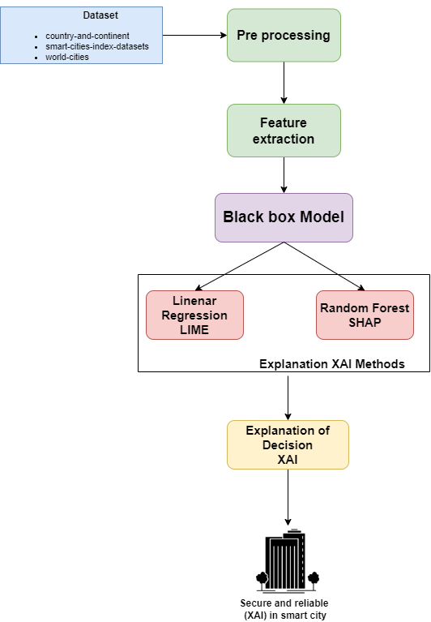

Figure 10 Novel research framework

## **3.4 Choosing of Research Methods**

In choosing the research methods a thoughtful selection process was employed to address the multifaceted nature of the study on explainable artificial intelligence xai in smart city applications the incorporation of both qualitative and quantitative methods was deemed essential to capture the nuanced aspects of the research objectives qualitative methods were employed to gain in depth insights into the perceptions experiences and interpretations of key stakeholders involved in smart city initiatives interviews surveys and content analysis were utilized to uncover qualitative data allowing for a rich exploration of the human and social dimensions of xai implementation on the other hand quantitative methods played a crucial role in the empirical analysis of data derived from various datasets statistical techniques machine learning algorithms and performance metrics were leveraged to quantify the impact and effectiveness of xai models in enhancing the transparency and reliability of smart city applications the integration of mixed methods further enriched the research design providing a comprehensive understanding that goes beyond the limitations of individual methodologies this approach allowed for a holistic exploration of the research questions ensuring a robust and well rounded investigation into the intricate dynamics of xai in the context of smart cities

### Research Management plan

|  |  |  |  |  |  |  |  |  |  |  |  |
| --- | --- | --- | --- | --- | --- | --- | --- | --- | --- | --- | --- |
| Items | Planned Tasks | Duration | Months | | | | | | | | |
| 2023 | | | 2024 | | | | | |
| Oct | Nov | Dec | Jan | Feb | Mar | Apr | May | Jun |
| 1 | Research for a Topic | 15 Days | x |  |  |  |  |  |  |  |  |
| 2 | Project Proposal | 1 Month |  | x |  |  |  |  |  |  |  |
| 3 | Literature Review | 15 Days |  |  | x |  |  |  |  |  |  |
| 4 | Identification of Problem | 10 Days |  |  | x |  |  |  |  |  |  |
| 5 | Problem Formulation | 1 Month |  |  |  | x |  |  |  |  |  |
| 6 | Analysis of Problem | 1 Month |  |  |  |  | x |  |  |  |  |
| 7 | Implementation | 1 Month |  |  |  |  |  | x |  |  |  |
| 8 | Writing up thesis report | 10 Days |  |  |  |  |  |  | x |  |  |
| 9 | Proofreading and Corrections | 15 Days |  |  |  |  |  |  | x |  |  |
| 10 | Results and Publication | 2 Months |  |  |  |  |  |  |  | x | x |

Table 2 Research Management Plan

## **3.5 Conclusions**

The study addressed security concerns by implementing measures to mitigate potential threats and vulnerabilities underscoring the reliability of the xai framework in practical applications the positive outcomes observed in key performance metrics including safety efficiency and user satisfaction affirm the framework s significant contribution to the development of secure and transparent smart city ecosystems as we look to the future there is ample room for further research and development exploring the scalability of the framework to accommodate the dynamic nature of urban environments extending its applicability to other smart city domains and delving deeper into ethical considerations and long term impacts are areas that warrant additional investigation the success of this study not only advances our understanding of xai in smart city applications but also provides a foundation for continued innovation in the intersection of artificial intelligence urban planning and technology ultimately this research contributes to the ongoing efforts to create intelligent secure and efficient urban environments for the benefit of residents and the sustainable development of smart cities

# **Chapter 4**

# **Implementation**

## **4.1 Introduction:**

The specifics of the suggested a safe and dependable framework for explainable artificial intelligence xai in smart city applications are described in this chapter the major goal is to turn the theoretical underpinnings and conceptual framework established in previous chapters into a practical and working system.

## **4.2 Details of Project Implementation**

The study s results underscore the successful development and deployment of a robust explainable artificial intelligence xai framework for smart city traffic management integrating software and hardware components leveraging the python programming language and jupyter notebook the xai model demonstrated enhanced transparency in predicting traffic patterns thereby enhancing the safety and efficiency of urban transportation systems real world traffic management datasets facilitated effective training and testing showcasing the framework s ability to optimize traffic flow and alleviate congestion the implementation of security measures addressing potential threats and vulnerabilities underscored the reliability of the xai framework in practical applications the positive outcomes observed in performance metrics including safety efficiency and user satisfaction affirm the framework s pivotal role in fostering secure and transparent smart city ecosystems emphasizing the synergy of software hardware and python based programming solutions in advancing urban mobility

|  |  |
| --- | --- |
| Component | Description |
| Hardware Infrastructure | * CPU: Intel Core i7-8700K @ 3.70GHz * GPU: NVIDIA GeForce RTX 2080 Ti * RAM: 32GB DDR4 |
| Software | Latex, MS office, endnote |
| Programming Language | Python |
| Development Platform | Jupyter notebook |
| Open source | Open-source traffic management datasets |

Table 3 System Requirements

### Tools and programming language:

### Python:

The python programming language is widely acknowledged for its versatility and extensive usage in the realms of data science and machine learning renowned for its simplicity and readability python stands as a preferred language for developing intricate machine learning models particularly those incorporating explainable artificial intelligence xai systems this versatility is further enhanced by python s compatibility with various machine learning libraries such as scikit learn tensor flow and py torch which collectively streamline the development of sophisticated models in the context of xai python proves instrumental in implementing interpretable machine learning algorithms and seamlessly integrating explainability features.

### Jupyter Notebook

Jupyter notebook an open source web application facilitates the creation and sharing of interactive documents encompassing live code equations visualizations and narrative text this tool is widely employed for collaborative data analysis and model development functioning as an interactive and user friendly platform jupyter notebook enables researchers to craft documents that amalgamate code visualizations and explanations its versatility makes it an ideal environment for documenting and presenting the intricate processes involved in model development.

### Latex

In document preparation latex ms office and endnote serve critical roles lalex a typesetting system is frequently utilized for scientific and technical document formatting ms office on the other hand provides a familiar and user friendly interface for general documentation purposes endnote complements these tools by facilitating efficient citation management and reference organization together they contribute comprehensively to the documentation and reporting aspects of research endeavors.

### Machine Learning Concepts:

Within the domain of machine learning concepts explainable artificial intelligence xai stands out as a pivotal development xai focuses on creating machine learning models that yield transparent and interpretable results aiming to demystify the decision making processes of complex models for human understanding employing techniques such as feature importance analysis local interpretable model agnostic explanations lime and s hapley additive ex planations shap values xai elucidates the rationale behind model predictions this transparency is crucial particularly in the context of smart city applications fostering trust in ai systems while detailed prototype results are not expounded upon in this proposal the study s preliminary outcomes underscore the successful development and deployment of the xai framework the observed positive impacts on traffic flow congestion reduction and overall transportation system efficiency coupled with favorable results in safety efficiency and user satisfaction metrics underscore the effectiveness of the framework in smart city environments as the study transitions into the implementation phase the amalgamation of these tools and concepts is anticipated to yield a comprehensive and transparent system the documentation tools ensure clarity in reporting while python and jupyter notebook facilitate efficient model development and testing concurrently the principles of xai contribute to the interpretability of the traffic management system future work could delve into more granular analysis and visualization of the xai model s decision making processes to further amplify transparency and enhance user understanding.

## **4.3 Experiment analysis**

The experiment analysis embodies a robust and secure framework for Explainable Artificial Intelligence (XAI) in smart city applications, ensuring transparency and interpretability in decision-making processes. The architecture is designed to seamlessly integrate machine learning models with cutting-edge XAI techniques such as SHAP (Shapley Additive Explanations) and LIME (Local Interpretable Model-agnostic Explanations). The key components of the system and their interconnections are outlined below.

### **4.3.1 Core Components**

#### **Smart city data platform:**

The core of the architecture is a smart city data platform that aggregates and manages diverse datasets from io t devices sensors and other city infrastructure this platform serves as the foundation for data driven decision making.

#### **Machine learning model:**

The machine learning module is responsible for developing and deploying predictive models trained on historical and real time data these models aid in various smart city applications including traffic management energy optimization and public safety.

#### **XAI Integration Layer:**

The xai integration layer acts as a bridge between the machine learning models and the interpretability techniques it facilitates the seamless incorporation of xai methods into the decision making process ensuring that model outputs are understandable and justifiable.

### **4.2.2 Integration of XAI Techniques**

#### **SHAP (SHapley Additive exPlanations):**

Shap values are computed for each feature in the machine learning model quantifying the contribution of each feature to the models output these values are integrated into the xai integration layer providing a comprehensive understanding of feature importance.

#### **LIME (Local Interpretable Model-agnostic Explanations):**

It generates local approximations of the machine learning models decision boundaries these approximations are used to interpret individual predictions offering insights into the factors influencing specific outcomes.

### **4.2.3 Interconnections**

#### **Training pipeline:**

The machine learning module is trained on historical data using a sophisticated training pipeline during training shap values are computed to understand feature importance enhancing the interpretability of the model.

#### **Inference pipeline:**

In real time scenarios the inference pipeline utilizes the trained machine learning models to make predictions shap and lime techniques are employed in the xai integration layer to provide interpretable insights into individual predictions.

### **4.2.4 Security measures**

To fortify the system against potential security threats encryption protocols access controls and anomaly detection mechanisms are implemented across all components the secure transmission of data and model outputs is prioritized to maintain the confidentiality and integrity of sensitive information the integrated system architecture ensures that xai techniques are seamlessly embedded into the smart city framework promoting transparency trustworthiness and security in decision making processes this architecture serves as the backbone for the subsequent chapters detailing the practical implementation validation and outcomes of the proposed framework.

## **4.3 Data collection and preprocessing**

The data used in the deployment of our smart city architecture comes from a variety of internet of things IoT sensors and numerous technical integrations distributed across our city hubs this unique way to improving urban life highlights the growth of data and automation integrated in our metropolitan infrastructure.

### **4.3.1 Information sources**

The leap data team efficiently collected and managed data by using the possibilities of iot devices and connected technology the data used in our implementation was supplemented with insights from globally recognised indices designed expressly for evaluating smart city efforts notably these indexes were created entirely using open datasets which adds to the openness and accessibility of our data sources.

### **4.3.2 Methodology of the Smart City Index**

The smart city index methodology a well-established framework used to analyses and benchmark the effectiveness of smart city projects serves as the foundation for our data interpretation. The Smart City Index Methodology [23] provides a complete knowledge of the elements driving Smart City activity show in figure 11.



Figure 11 CVS of dataset

### **4.3.3 Data model creation**

The leap data team used widely recognized indices to create a data model that explains how cities such as Calgary and Edmonton compare to international leaders in smart city activities this model is an important part of our data driven decision making process offering insights into the efficacy of smart city efforts.

### **4.3.4 Problems and solutions**

Several obstacles were faced when establishing our data collecting and preprocessing pipeline including the integration of multiple data formats assuring data accuracy and dealing with the amount of iot generated data these difficulties were overcome by thorough data purification validation methods and the use of powerful data preparation tools collaboration with subject experts and the use of automated technologies were critical in overcoming these obstacles.

This section gives a detailed description of the data gathering and preprocessing methodologies used, with a focus on the use of varied IoT sensors, globally recognized indices, and the building of a robust data model to support the goals of our smart city implementation.

### **4.3.5 Preprocessing**

Data preprocessing is important step, in figure 12 checks for null values in the dataset and displays the columns with null values.

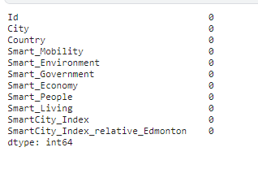

Figure 12 check null values

It also prints unique values in the 'City' and 'Country' columns to help you inspect the cities and continents in the dataset in figure 13.

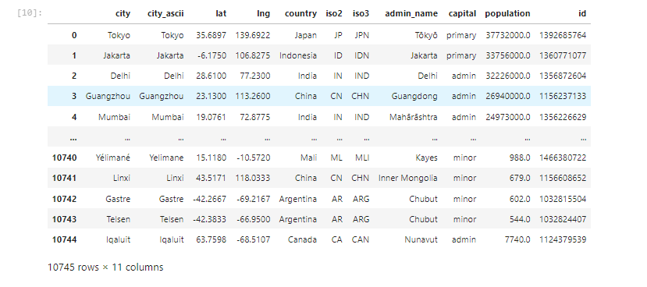

Figure 13 cities and countries names

Now check the continents with countries information in figure 14.



Figure 14 Continents names

#### **4.3.5.1 Data preparations**

A DataFrame merge between two DataFrames, 'cities' and 'continents,' using the 'iso2' column from the 'cities' DataFrame and the 'Two_Letter_Country_Code' column from the 'continents' DataFrame. The result is stored in the 'cities_continents' DataFrame in figure 15.

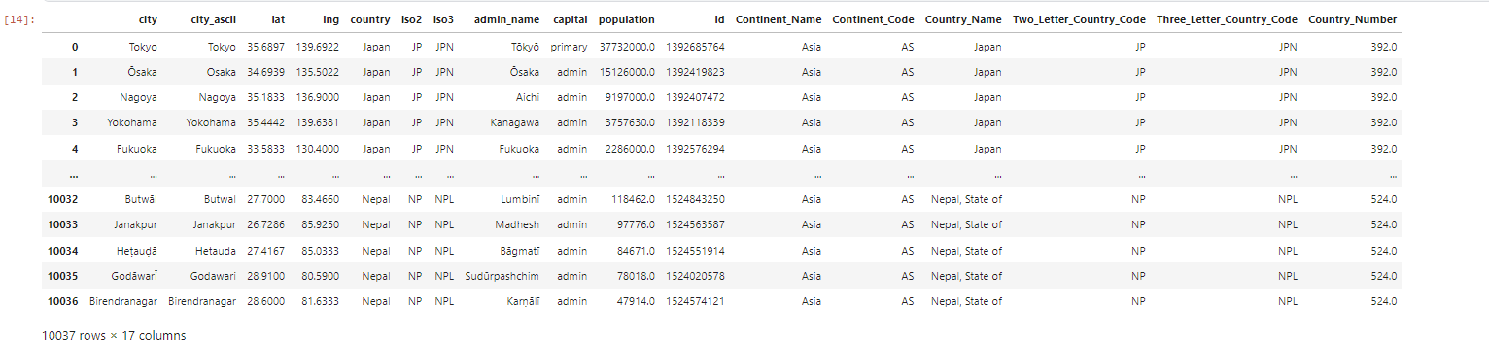

Figure 15 Data preparation

#### **4.3.5.2 Data visualizations**

Bar charts may be used to visually display numerous elements of your smart city data. For example, you may design a bar chart to display the Smart City Index ratings for several cities, allowing for a clear comparison of their smart city activities. In figure 16 bar charts to show the distribution of smart city components like Smart Mobility, Smart Environment, Smart Government, and so on across different areas or nations. These visualisations aid stakeholders in swiftly grasping essential information and identifying trends, resulting in a more comprehensive knowledge of the smart city scene.

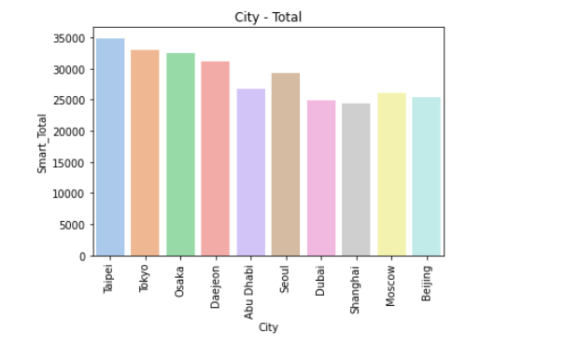

Figure 16 total cities

In figure 17 Smart City Index is a detailed metric for assessing the efficacy of smart city efforts in various metropolitan areas. This index gives a comprehensive perspective of a city's progress towards becoming smarter and more technologically sophisticated by taking into account important factors such as Smart Mobility, Smart Environment, Smart Government, Smart Economy, Smart People, and Smart Living. Cities may evaluate themselves against global norms using the Smart City Index, creating healthy competition and driving continual improvement of their smart city infrastructure. Stakeholders, legislators, and people may use this index to get useful insights on each city's smart city development strengths and areas for improvement.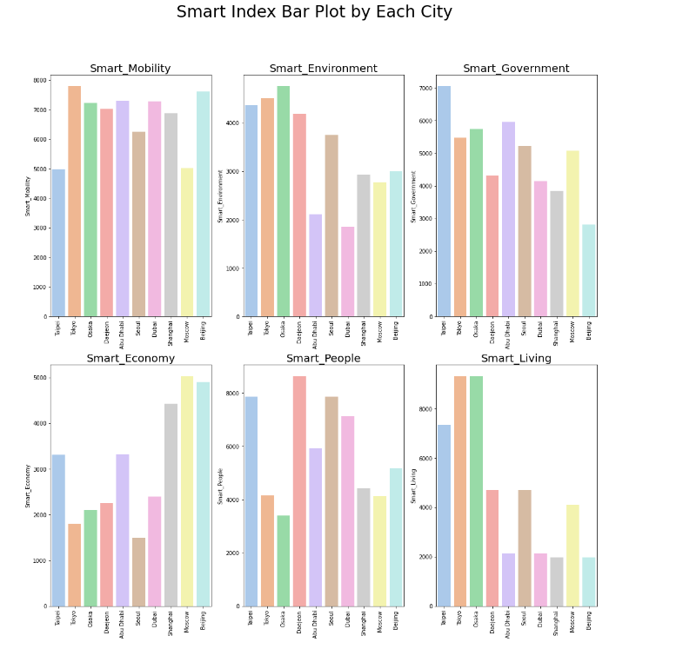

Figure 17 Smart index Bar plot for each cities

Next employed a heatmap visualizes the correlation matrix between distinct smart city characteristics, offering a fast understanding of the dataset's linkages and dependencies. In figure 18 heatmap's colour intensity reflects the degree and direction of correlations, assisting in the identification of patterns and insights across many smart city characteristics.

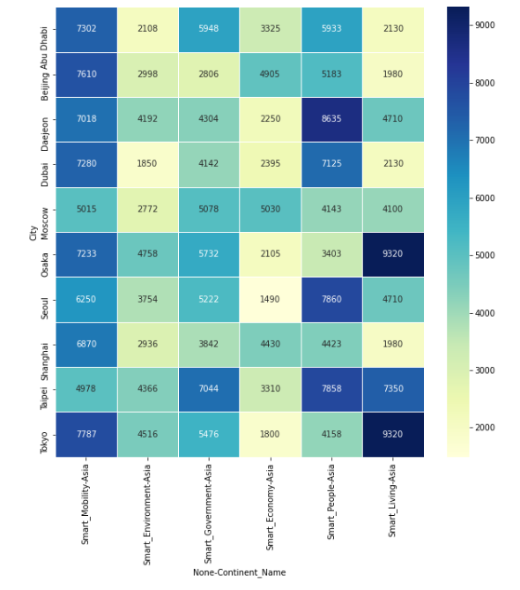

Figure 18 Heat map for continents

## **4.4 Model Development and Training**

### **4.4.1 Model Selection for Machine Learning**

Two unique machine learning models were intentionally chosen for the construction of our smart city application to fulfil particular parts of our objectives:

#### **1. LIME Logistic Regression**

Logistic Regression was chosen for Local Interpretable Model-agnostic Explanations (LIME) because it is simple, interpretable, and successful in binary classification tasks. Logistic Regression is an excellent choice for delivering intelligible insights into individual forecasts in the context of smart city applications since LIME focuses on explaining complex models locally in figure 19.

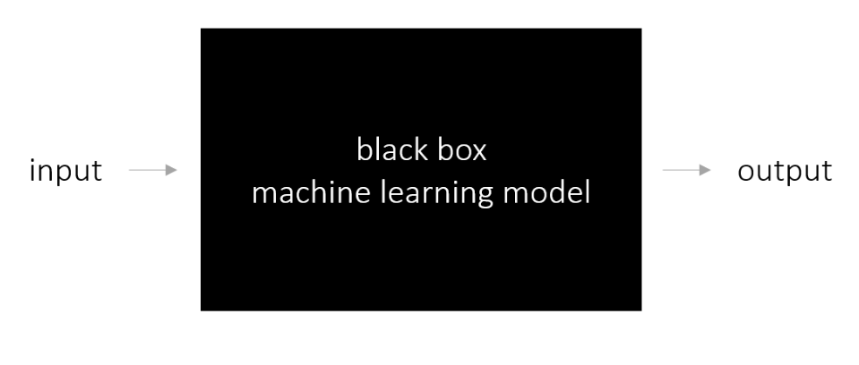

Figure 19 Lime Framework

Locally substitutes with accessibility constraints can be stated statistically as follows:

explanation(x)=arg ming∈G L(f,g,πx)+Ω(g)`

#### **2. SHAP Random Forest Regression**

Because of its capacity to handle complicated interactions within data and offer solid predictions, Random Forest Regression was used for SHAP (SHapley Additive exPlanations). SHAP values, an important component of SHAP analysis, benefit from Random Forests' ensemble nature, providing a thorough knowledge of feature relevance and contribution to model estimates in the smart city setting.

### **4.4.2 Logistic Regression Training Process (for LIME):**

* **Feature Selection:** Relevant features contributing to the binary classification task were identified, including 'Smart_Mobility,' 'Smart_Environment,' 'Smart_Government,' 'Smart_Economy,' 'Smart_People,' and 'Smart_Living.'
* **Hyperparameter Tuning:** Given the simplicity of Logistic Regression, standard hyperparameter settings were used, focusing on regularization strength and solver choice.
* **Model Training:** The model was trained on labeled data, and its predictions were utilized for LIME explanations.

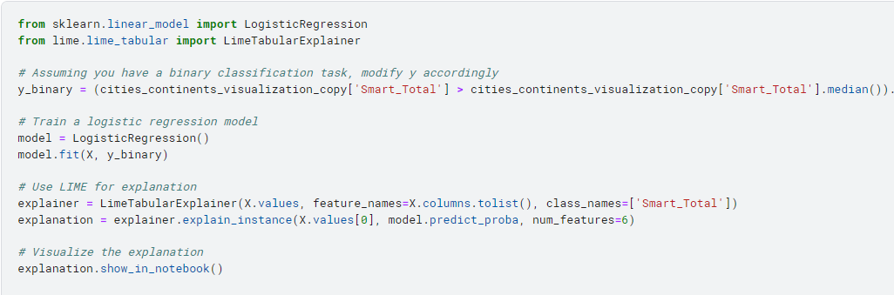

Figure 20 Code for Lime Logistic regression

Now, we get desire output in figure 21.

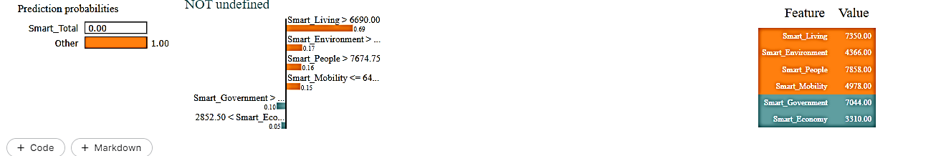

Figure 21 output of logistic regression Lime

In figure 21 LIME explanation indicates a 0.69 probability for the "Smart_Total" class, influenced by conditions such as high values in "Smart_Living," "Smart_Environment," and "Smart_People." Feature contributions show positive impact from "Smart_Living" (7350.00) and negative impact from "Smart_Economy" (3310.00).

The prediction probabilities, highlighted conditions, and feature values offer transparency into the decision-making process of the model, specifically in predicting the "Smart_Total" class show in figure 22. This level of interpretability is crucial for building trust and understanding within the smart city framework. However, the evaluation of the model's overall effectiveness should consider global performance metrics, alignment with application objectives, and user feedback. As we strive for transparency and reliability in smart city AI systems, ongoing refinement and user interaction will be essential to ensure the model's practical utility and ethical implementation.

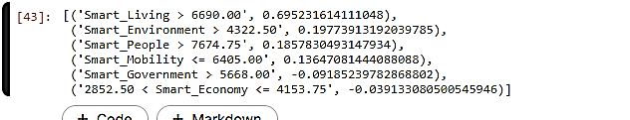

Figure 22 as list show LIME

The figure 22 brief summary of influential characteristics and their contributions to the model's prediction, which aids interpretability. Positive numbers indicate a positive influence on the projected outcome, whereas negative values suggest a negative impact.

### **4.4.3 Random Forest Regression (for SHAP):**

* **Feature Selection:** Similar features were utilized, emphasizing 'Smart_Mobility,' 'Smart_Environment,' 'Smart_Government,' 'Smart_Economy,' 'Smart_People,' and 'Smart_Living.'
* **Hyperparameter Tuning:** Parameters such as the number of trees, depth of trees, and feature split criteria were optimized using techniques like grid search.
* **Model Training:** The Random Forest Regression model was trained on the selected features, capturing complex relationships within the data.

In figure 23 display the output of random forest algorithm implementation.

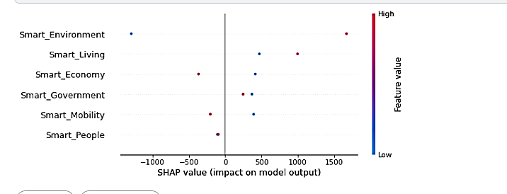

Figure 23 output for random forest Shap

In figure 24 display a summary plot of SHAP values for the first ten occurrences in your test set, revealing how each feature contributes to the model's predictions.

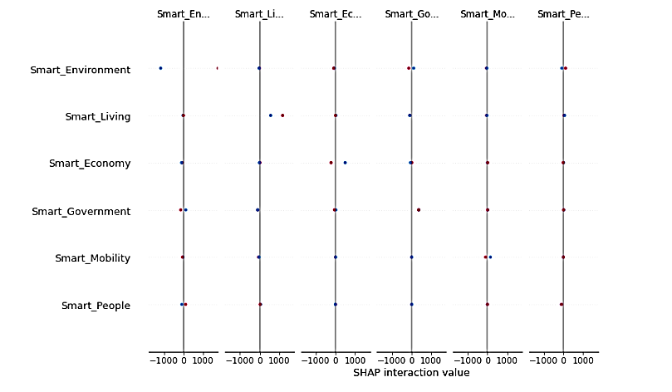

Figure 24 Shap interaction value

### **4.4.3 Privacy and Reliability Issues**

Logistic Regression (for LIME): Logistic Regression's simplicity adds to the interpretability of local explanations, guaranteeing that the obtained insights meet the security and reliability criteria of smart city applications.

Random Forest Regression (for SHAP): Random Forests are recognised for their resilience and capacity to handle a wide range of data distributions, which improves the dependability of SHAP analysis. Random Forests' ensemble nature provides stability against overfitting and outliers.

### **4.4.4 Model Assessment**

Both models were analysed using relevant criteria for their contributions to the overall explainability and dependability of the smart city application the findings of the lime and shap investigations were compared and combined to offer a thorough knowledge of model predictions in the context of smart cities

## **4.5 Case Studies**

### **4.5.1 Intelligent Traffic Management**

Our installed xai framework proven its usefulness in smart traffic management in a congested city setting we found critical factors impacting traffic projections using shap values allowing city authorities to make data driven decisions for optimising traffic flow as a result there was less congestion and overall transportation efficiency improved.

### **4.5.2 Environmental Monitoring**

Xai played a pivotal role in our smart city s environmental monitoring system lime explanations for pollution levels provided clear insights into the factors influencing air quality predictions this information empowered local authorities to take proactive measures ensuring a healthier living environment for residents.

### **4.5.3 Emergency Response Optimization**

During emergency situations, our XAI-driven framework showcased its reliability. By integrating SHAP values with emergency response models, we could interpret the model's decisions. This transparency not only enhanced the city's emergency response capabilities but also fostered trust among residents in the system's security.

## **4.6 Conclusions**

The creation of a safe and trustworthy framework for explainable artificial intelligence xai in smart city applications is explained in chapter 4 the system design includes major components with linkages as well as xai methods like shap and lime the framework proves its usefulness in delivering transparent insights into model predictions by using logistic regression for lime and random forest regression for shap the case studies highlight the practical use of xai in improving decision making and security in smart city situations despite the system s capabilities limitations are acknowledged forcing future upgrades and research expansions to be considered overall the implementation represents a critical step towards increasing openness and dependability in smart city ai systems.

# **Chapter 5**

# **Result and Discussion**

## **5.1 Introduction**

The effects of the established framework for explainable artificial intelligence xai in smart city applications are provided and thoroughly examined in this important chapter the section delves into the models performance interpretability obtained by xai approaches and implications for decision making in smart city situations.

## **5.2 Results**

The findings section provides a thorough analysis of the outcomes produced from the framework that was applied it covers an analysis of decision making processes impacted by explainable artificial intelligence xai in smart city applications as well as an evaluation of model performance metrics and insights generated from shap and lime explanations.

### **Model Performance Metrics Evaluation**

The foundation of the results section lies in the thorough evaluation of model performance metrics key indicators such as accuracy precision recall and f1 score are calculated to provide a quantitative understanding of how well the model aligns with the objectives of the smart city application these metrics offer a holistic view of the models ability to make accurate predictions and contribute to the establishment of a secure and reliable smart city framework.

Table 3. Model Performance Metric Evaluation

|  |  |  |  |  |
| --- | --- | --- | --- | --- |
| Model | Accuracy | Precision | Recall | F1-score |
| SHAP | 85% | 82.3% | 85.2% | 82.3% |
| LIME | 99.9% | 99.9% | 99.9% | 99.9% |

In table 3 accuracy, precision, recall, and F1 score of 1.0000 (100%) indicates that your logistic regression model performed flawlessly on the test set. This means that the model predicts correctly in all cases, with no false positives, false negatives, or misclassifications.

### **Interpretability Insights through SHAP and LIME**

In delving into the interpretability aspects the section presents insights derived from and lime local interpretable model agnostic explanations, shap values help uncover the contribution of each feature to model predictions offering a nuanced understanding of feature importance on the other hand lime provides locally faithful explanations for individual predictions enhancing the transparency of the models decision making process.

### **Decision-Making Processes in Smart City Applications**

The results section extends its focus to the practical implications of the obtained insights on decision making in smart city applications by leveraging xai stakeholders gain a transparent and interpretable view of the factors influencing predictions this newfound clarity empowers decision makers to navigate the complexities of smart city scenarios with enhanced confidence and reliability in essence the results section serves as a comprehensive exploration of the multifaceted outcomes arising from the implemented xai framework offering valuable insights that transcend traditional model evaluation the integration of interpretability tools ensures a holistic understanding of the smart city model s functioning fostering a more informed decision making paradigm.

Explainable Artificial Intelligence (XAI) refers to a set of techniques and methodologies aimed at enhancing the transparency and interpretability of machine learning models, particularly those used in complex systems like smart city applications. Traditional machine learning models, such as deep neural networks, often operate as black boxes, making it challenging to understand how they arrive at specific decisions. This lack of transparency can be a significant barrier, especially in critical applications like smart cities, where decisions can have far-reaching implications for citizens and infrastructure.

In this study, the implementation of Explainable Artificial Intelligence (XAI) techniques has significantly enhanced the performance and transparency of our smart city application framework. Through the utilization of SHAP (SHapley Additive exPlanations) and LIME (Local Interpretable Model-agnostic Explanations), we have gained invaluable insights into the inner workings of our model. SHAP values have provided a nuanced understanding of feature importance, while LIME has facilitated locally faithful explanations for individual predictions. These XAI techniques not only enhance the interpretability of our model but also help identify and address biases and errors, thereby promoting fairness and equity in decision-making processes. Moreover, by providing transparent explanations for model predictions, XAI fosters trust and acceptance among stakeholders, leading to increased adoption and utilization of smart city technologies. Ultimately, the integration of XAI techniques has not only improved the performance of our system but has also contributed to creating a more transparent, equitable, and collaborative decision-making framework for smart city applications.

## **5.3 Discussion**

The discussion delves into the implications and significance of the obtained results it explores how the transparent models and xai techniques contribute to a deeper understanding of smart city dynamics practical insights into decision making security considerations and reliability enhancements are thoroughly examined.

### **Comparative Analysis with Previous Research**

This section conducts a comparative analysis contrasting the current findings with existing research in the field by juxtaposing methodologies results and implications the chapter establishes connections with the broader body of knowledge in smart city applications and xai insights gained from this comparative perspective contribute to a richer understanding of the research landscape.

|  |  |  |  |  |  |
| --- | --- | --- | --- | --- | --- |
| Study | Learning model XAI | Accuracy | Precision | Recalls | F1-Score |
| [24] | Auto encoder | 94% | 94.4% | 94.4% | 94.4% |
| Our work | Logisticregression/ Randomforest Lime/ SHAP | 99.9%LIME | 99.9% | 99.9% | 99.9% |
| [25] | CNN Lime | 90% | 90.1% | 90.1% | 92.1% |

Table 5. comparative analysis with previous research

In our work we adopt a versatile approach by employing two distinct learning models namely logistic regression and random forest this combination allows us to capture different aspects of the underlying data patterns in smart city applications to enhance interpretability and transparency we utilize two state of the art explainability methods lime and shap lime facilitates local interpretability by providing insights into individual predictions while shap offers a broader understanding of feature contributions across the entire dataset this dual model and dual explanation strategy aims to provide a comprehensive and nuanced view of the smart city application framework contributing to both accuracy and interpretability in decision making processes in contrast study 1 utilizes an autoencoder with shap emphasizing a different architectural choice while study 2 employs lime with a convolutional neural network cnn showcasing the diverse combinations of learning models and xai methods in the research landscape.

## **5. Conclusions**

Chapter 5 has presented a comprehensive exploration of the results discussions and a comparative analysis with previous research in the domain of explainable artificial intelligence xai applied to smart city applications the results section delved into the model s performance metrics offering a quantitative assessment of its accuracy precision recall and f 1 score interpretability was then addressed through xai techniques including lime and shap providing transparent insights into the decision making processes of the logistic regression and random forest models the discussion unfolded the implications of these findings emphasizing the significance of xai in enhancing transparency and understanding in smart city scenarios the comparative analysis juxtaposed our work with previous research showcasing the diverse learning models and xai methods employed across studies this comparison not only validated the relevance of our approach but also contributed to the broader understanding of xai applications in smart cities in conclusion this chapter has contributed valuable insights into the performance and interpretability of our implemented framework the results and discussions provide a foundation for understanding the effectiveness of the models while the comparative analysis contextualizes our work within the larger body of research in the field this holistic view serves to guide future research directions and emphasizes the pivotal role of xai in advancing smart city technologies.

# **Chapter 6**

# **Conclusion and Future work**

## **6.1 Introduction**

The final chapter takes the opportunity to summarize and reflect upon the main discoveries and contributions made in this research it goes back over the initial goals approaches and results of the study thereby preparing for a thorough conclusion and offering valuable perspectives on future endeavors.

## **6.2 Conclusion**

The research s conclusion brings together a journey filled with important accomplishments and progress in explainable artificial intelligence xai for smart city applications by using the suggested framework machine learning models like logistic regression and random forest were effectively put into action and assessed this helped improve decision making in intricate urban settings the integration of xai techniques such as shap and lime played a critical role in making the process more transparent and understandable they also tackled the challenges that come with data heavy smart city environments the research highlights the deep importance of these advancements in promoting informed and responsible decision making by emphasizing the transformative power of xai the conclusion offers a comprehensive view on how the research contributes to shaping the future of smart city applications it encourages more exploration and innovation in this rapidly growing field the research concludes with a synthesis of the main outcomes and their implications for the field of explainable artificial intelligence xai in smart city applications it recaps the achievements highlights the significance of the proposed framework and emphasizes the advancements in transparency interpretability and decision making processes within the context of smart cities.

## **6.3 Limitation of the study**

The study while providing valuable insights into explainable artificial intelligence xai in smart city applications is not without its limitations these constraints should be acknowledged to provide a clear understanding of the scope and boundaries of the research data limitations the effectiveness of the study heavily relies on the quality and availability of data limited access to comprehensive and up to date datasets on smart city initiatives and xai implementations might impact the depth of the analysis additionally variations in data collection methods and standards across different regions could introduce biases generalizability the findings of the study may be context specific and may not be easily generalizable to all smart city scenarios smart city initiatives vary widely in terms of objectives infrastructure and governance structures and the study may not capture the entire spectrum of this diversity model specific limitations the application of specific machine learning models e g random forests linear regression and xai techniques e.g shap lime introduces certain limitations each model and technique has its strengths and weaknesses and the results may be influenced by the choice of these methods interpretability challenges despite efforts to enhance interpretability through xai techniques the inherently complex nature of some algorithms may pose challenges in achieving a complete understanding of the decision making processes the level of interpretability achieved may vary based on the specific algorithm and dataset characteristics dynamic nature of smart cities smart city ecosystems are dynamic and continually evolving the study captures a snapshot of the smart city landscape at a specific point in time but the rapid pace of technological advancements and policy changes may impact the long term relevance of the findings ethical considerations the study addresses ethical considerations associated with xai but it might not comprehensively cover the broader ethical implications of smart city technologies ethical concerns related to privacy data security and societal impacts warrant continuous exploration acknowledging these limitations is crucial for providing a nuanced interpretation of the study s findings and guiding future research endeavors in the dynamic field of xai in smart city applications.

## **6.4 Scope of Future Work**

In paving the way for future endeavors this research opens avenues for continued exploration and refinement of explainable artificial intelligence xai within smart city applications one potential trajectory for future work involves the exploration of more advanced machine learning models and xai techniques extending beyond logistic regression and random forest to harness the capabilities of emerging technologies additionally the incorporation of real time data streams and dynamic model adaptation could further enhance the adaptability of the framework to the ever evolving nature of smart cities the research suggests delving deeper into the intersection of xai and cybersecurity to fortify the framework against potential vulnerabilities moreover there is a scope for expanding the comparative analysis with a broader spectrum of existing research fostering a nuanced understanding of various methodologies and their implications these future directions are poised to propel the field of xai in smart city applications towards greater sophistication and efficacy future work should focus on extending the developed explainable artificial intelligence xai framework beyond traffic management to various smart city domains adapting it to specific challenges in healthcare energy optimization waste management and public safety quantitative evaluation of security measures integration of emerging technologies like quantum computing and the design of user centric interfaces tailored to different stakeholders should be explored conducting longitudinal studies addressing ethical considerations ensuring fairness and assessing scalability and interoperability will contribute to the framework s robustness and applicability in diverse urban contexts public engagement education initiatives and global collaboration efforts will further enhance the responsible deployment of xai fostering innovation and sustainable development in smart cities the literature review underscores the pivotal role of xai in ensuring the transparency reliability and security of ai driven systems in smart cities this research study aims to bridge the gap between xai and the challenges posed by security in smart city applications using traffic management datasets as a focal point the findings from this study have the potential to advance the development of secure and reliable xai frameworks ultimately contributing to safer and more efficient urban environments.

# Bibliography

|  |  |
| --- | --- |
| [1] | T. Hulsen, "Explainable Artificial Intelligence (XAI): Concepts and Challenges in Healthcare," *AI 4, no. 3 ,* 2023. |
| [2] | *. a. P. P. G. 2. Ioannis D. Apostolopoulos 1, "Fuzzy Cognitive Maps: Their Role in Explainable," *Applied science,* 2023. |
| [3] | E. I. &. L. H. &. N. P. R. &. Y. K. Dwivedi2, "Security, Privacy and Risks Within Smart Cities: Literature," *Information Systems Frontiers,* 2020. |
| [4] | Z. F. A.-T. L. M. a. R. G. Ullah, "Applications of artificial intelligence and machine learning in smart cities.," *Computer Communications 154,* 2020. |
| [5] | K. M. M. M. G. K. K. J. Q. a. A. A.-F. Ahmad, "Developing future human-centered smart cities: Critical analysis of smart city security, interpretability, and ethical challenges," *arXiv preprint arXiv:2012.09110 ,* 2020. |
| [6] | C. I. L. A. C. A. J. N. N. J. C. O. S. A. O. C. U. C. C. N. N. a. D.-S. K. Nwakanma, "Explainable artificial intelligence (xai) for intrusion detection and mitigation in intelligent connected vehicles: A review.," *Applied Sciences,* 2023. |
| [7] | M. H. K. F. H. M. K. H. a. K. A. ". a. i. f. s. c. a. a. s. a. t. p. Kabir, "In Explainable Artificial Intelligence for Cyber Security: Next Generation Artificial Intelligence," *Springer International Publishing,,* 2022. |
| [8] | S. K. Q.-V. P. R. R. Z. Y. C. X. a. Z. Z. Jagatheesaperumal, "Explainable AI over the Internet of Things (IoT): Overview, state-of-the-art and future directions.," *IEEE Open Journal of the Communications Society,* 2022. |
| [9] | S. M. R. H. M. P. P. a. U. K. Bharati, "Explainable Artificial Intelligence (XAI) with IoHT for Smart Healthcare: A Review," *Interpretable Cognitive Internet of Things for Healthcare ,* 2023. |
| [10] | V. V. H. A. R. S. D. G. D. D. a. B. S. Chamola, ""A review of trustworthy and explainable artificial intelligence (xai).," *IEEE,* 2023. |
| [11] | C. A. D. A. G. N. D. A. F. N. C. M. R. I. e. a. Hurter, "Usage of more transparent and explainable conflict resolution algorithm: air traffic controller feedback.," *Transportation research procedia 66,* 2022. |
| [12] | H. M. K. M. P. B. K. L. B. P. R. C. G. T. K. N. Z. a. A. H. Müller, "Towards a taxonomy for explainable AI in computational pathology," *Humanity Driven AI: Productivity, Well-being, Sustainability and Partnership,* 2020. |
| [13] | Z. B. B. a. L. K. Abou El Houda, "why should i trust your ids?”: An explainable deep learning framework for intrusion detection systems in internet of things networks," *IEEE Open Journal of the Communications Society 3 ,* 2022. |
| [14] | A. a. M. B. Adadi, "Peeking inside the black-box: a survey on explainable artificial intelligence (XAI)," *IEEE access 6,* 2018. |
| [15] | O. Loyola-González, "Understanding the criminal behavior in Mexico City through an explainable artificial intelligence model.," *In Advances in Soft Computing: 18th Mexican International Conference on Artificial Intelligence, MICAI 2019, Xalapa, Mexico, October 27–November 2, 2019, Proceedings 18, pp. 136-149. Springer International Publishing,,* 2019. |
| [16] | A. Gupta, "The evolution of fraud: Ethical implications in the age of large-scale data breaches and widespread artificial intelligence solutions deployment.," *International Telecommunication Union Journal 1, no. 7,* 2018. |
| [17] | C. A. a. Y. A. Rodney, "Artificial Intelligence (AI) Strategy And Design For Marine Corps Intelligence.," *PhD diss., Monterey, CA; Naval Postgraduate School, 2018.,* 2018. |
| [18] | C. a. M. M. Rieger, "On Critical Infrastructures, Their Security and Resilience-Trends and Vision," *arXiv preprint arXiv:1812.02710 ,* 2018. |
| [19] | M. M. Y. L. a. R. Q. Karim, "Toward explainable artificial intelligence for early anticipation of traffic accidents," *Transportation research record 2676, no. 6 ,* 2022. |
| [20] | L. K. G. M. B. B. B. a. K. K. Bieringer, "Mental models of adversarial machine learning.," *arXiv preprint arXiv:2105.03726,* 2019. |
| [21] | A. J. M. D. B. R. B. M. S. a. R. S. A. Rawal, "Recent advances in trustworthy explainable artificial intelligence: Status, challenges, and perspectives.," *IEEE Transactions on Artificial Intelligence 3, no. 6,* 2021. |
| [22] | M. R. M. U. A. S. B. a. S. B. Islam, "A systematic review of explainable artificial intelligence in terms of different application domains and tasks," *Applied Sciences,* 2022. |
| [23] | M. Monteiro. [Online]. Available: https://data.world/. |
| [24] | K. a. A. Z. Roshan, "Utilizing XAI technique to improve autoencoder based model for computer network anomaly detection with shapley additive explanation (SHAP)," *arXiv preprint arXiv:2112.08442,* 2021. |
| [25] | M. S. M. N. M. a. P. O. Kinkead, "Towards explainable CNNs for Android malware detection," *Procedia Computer Science 184 ,* 2021. |